23.8: From Example 23.1, the initial energy 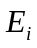can be calculated:
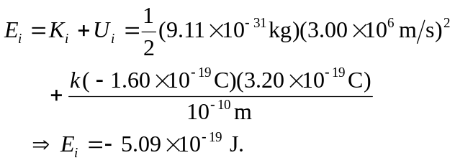
When velocity equals zero, all energy is electric potential energy, so:
